Fall 2024 CV team Letter
Our annual Wisconsin ACC chapter meeting was a success on 10/5/24. Please see pictures below
Thank you for all CV team members who participated.
Below is Lana Zaharova, NP CV team liaison at WI chapter
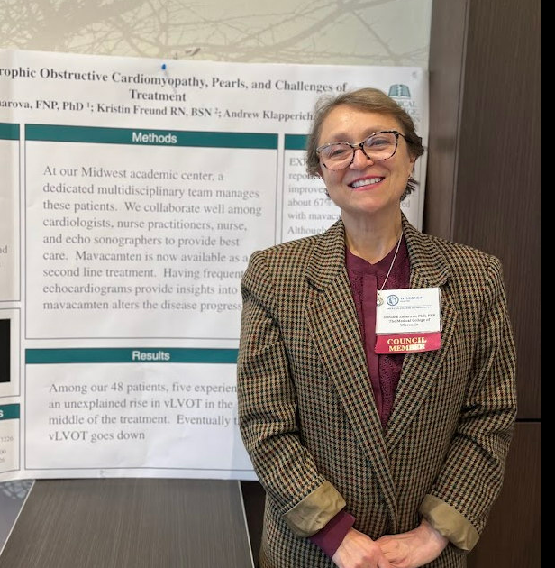
On picture below is our present Governor Dr Renuka Jain on the right and our Governor-Elect Dr. Ann O’Connor – on the left of Dr Jain
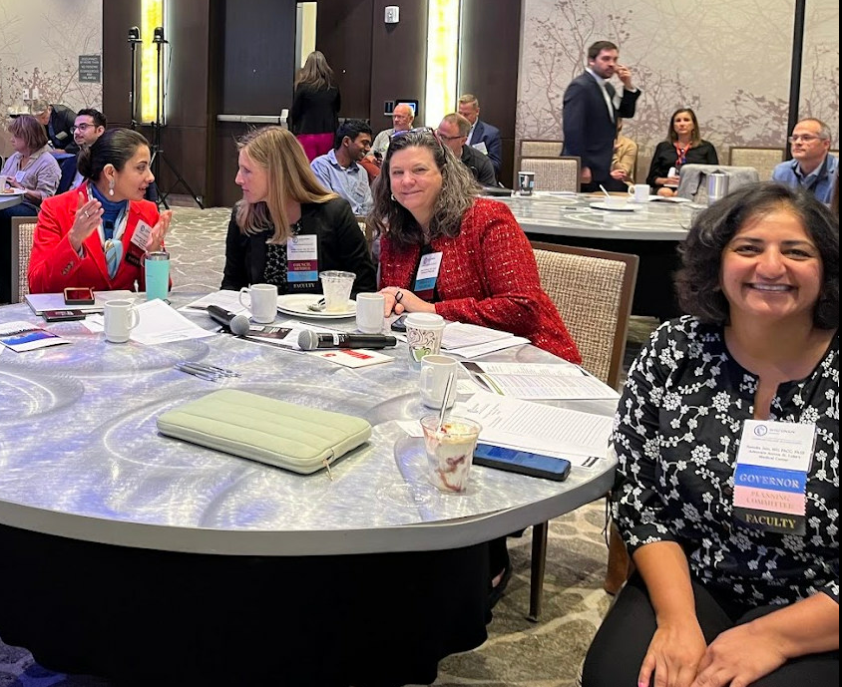
Please do not forget ACC25 is in Chicago next year, no excuse not to attend, and CV team lounge is the best.

We would love to see you all and mingle.
Please remember till 11/20/24 there is a discount rate to register for CV members. It is $449 instead of $499.
And choice of hotels to stay for now is endless.

Please let me know at szaharov@mcw.edu, if you have questions.

